Familiarizing yourself with the interface

Configuration window

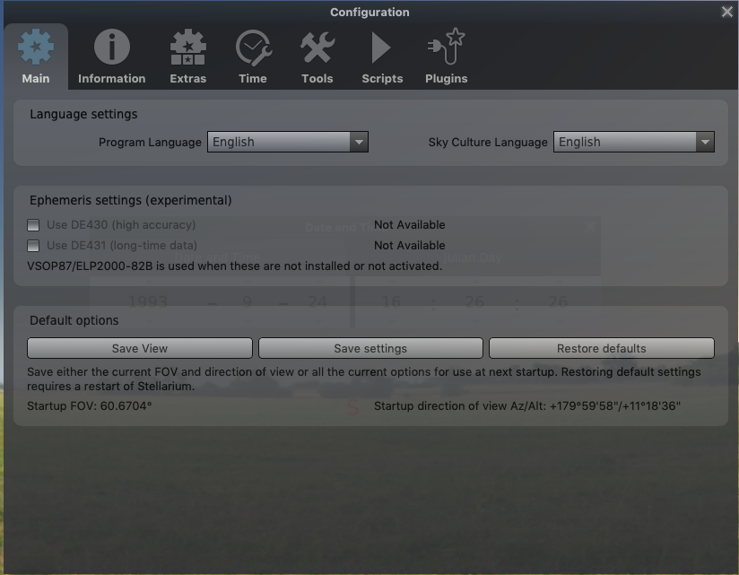

Task 1: Set program language and skyculture language to English

1. Go to Main tab
2. Choose English under Program Language
2. Choose English under Sky culture Language

Task 2: Limit the information displayed to have a better view

1. Go to Information tab
2. Select Short
3. Make sure Catalogue number(s) is ticked
3. Go back to the Main tab and click Save View and Save Settings. Close Window

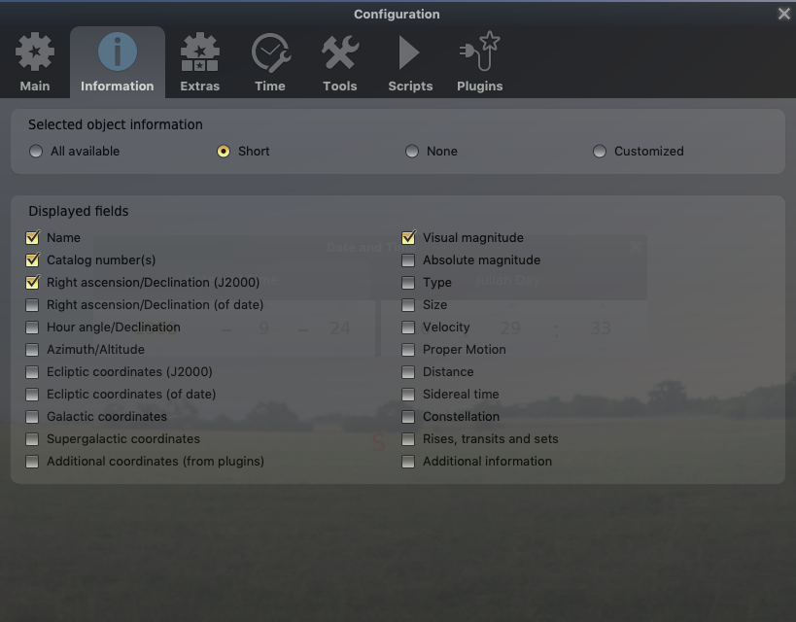

Location window

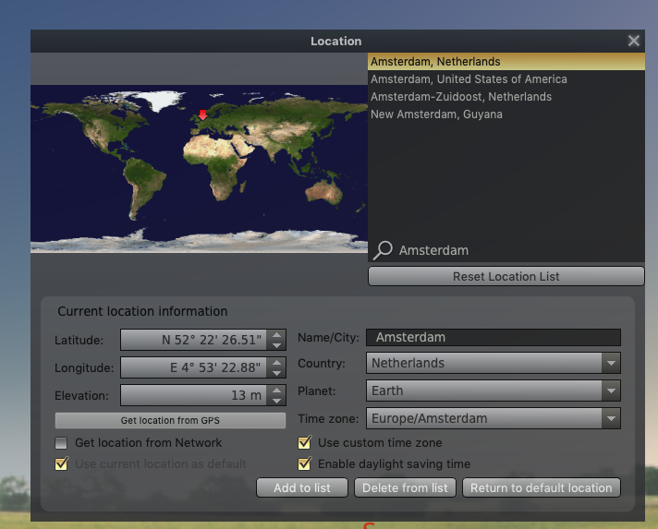

Task 3: Make Amsterdam your default location

1. In search box type: Amsterdam
2. Select the option: Amsterdam, Netherlands
3. Tick the box: Use current location as default
4. Close window

Result: on the main screen you should see your location in the left corner:
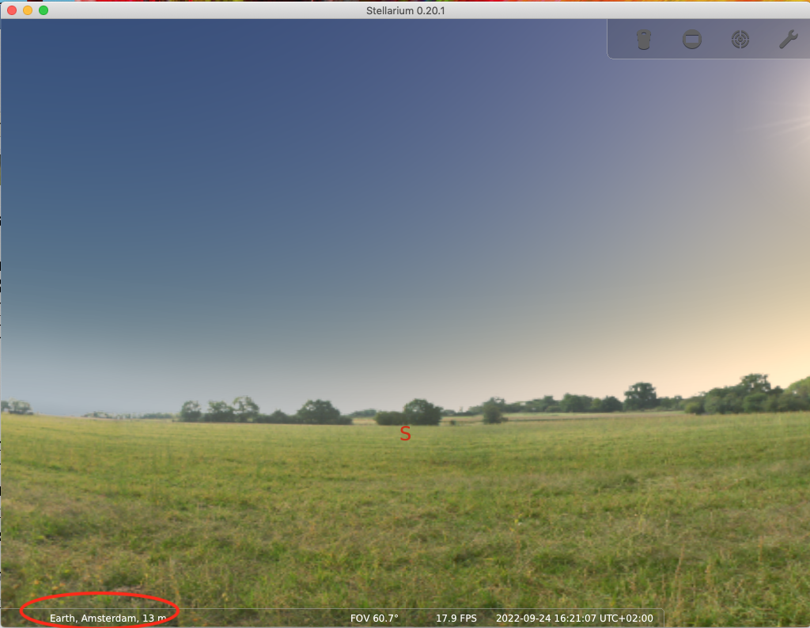

Sky and viewing options window

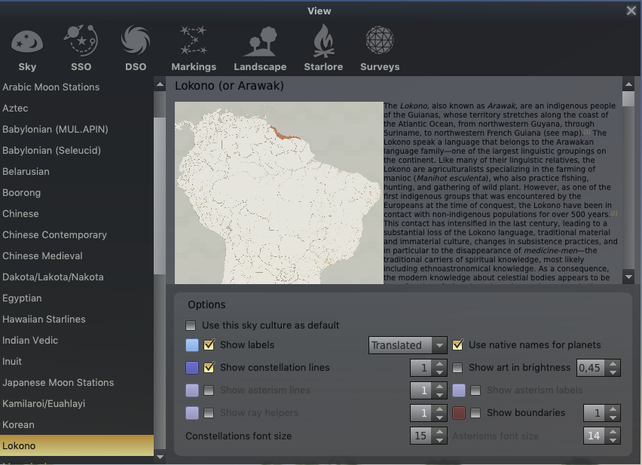

Task 4: Select the Lokono skyculture

1. In the left-hand column select Lokono
2. Tick Show labels and select Native
3. Tick Use native names for planets
4. Tick Show constellation lines
5. Close window

Result: you may see nothing, that’s OK:
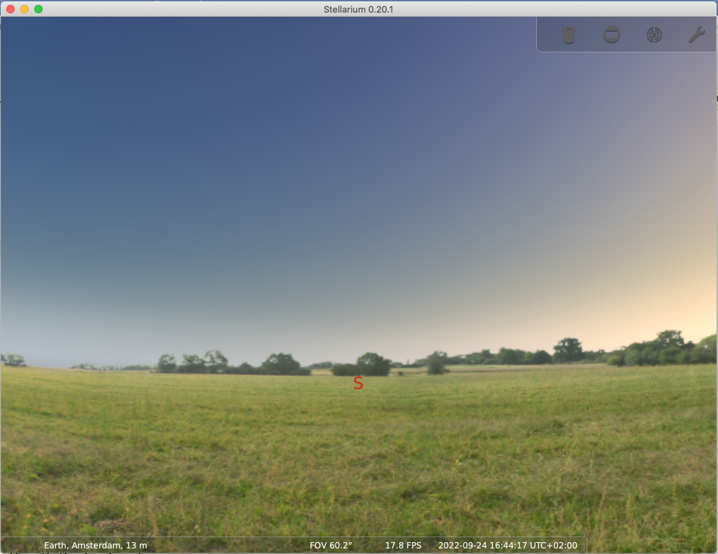

Adjust viewing options

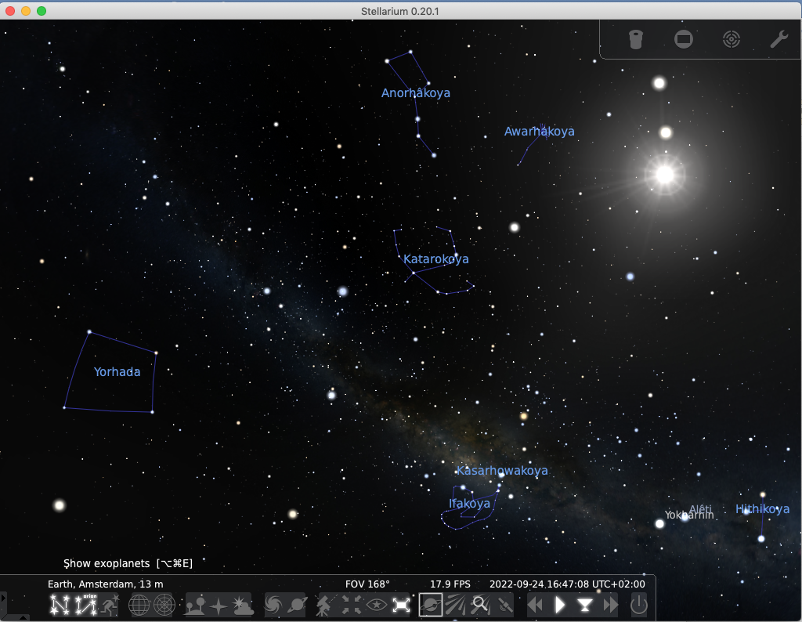

Task 5: Turn off all unnecessary functions on the lower menu bar:

1. Turn off (from left to right):
- Equatorial grid
- Azimuthal grid
- Ground
- Atmosphere
- Deep-sky objects
- Planet labels
- Cardinal points
- …

2. Keep on:
- Constellations lines
- Constellation labels

Adding a new skyculture

Rename your skyculture

Task 6: Rename your skyculture

1. Navigate to the lokono_name folder you saved on your computer
2. Replace name in the name of the folder to with your name (e.g. lokono_john)
3. Open the renamed lokono_name folder
4. Right-click the info.ini file and open it in your text editor
5. Change the value in the field name to Lokono_name (e.g. Lokono_john)
6. Close and save file

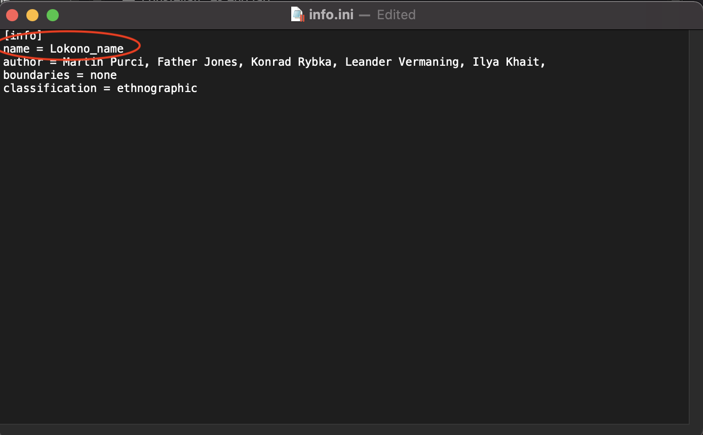

Add your skyculture folder to the Stellarium folder

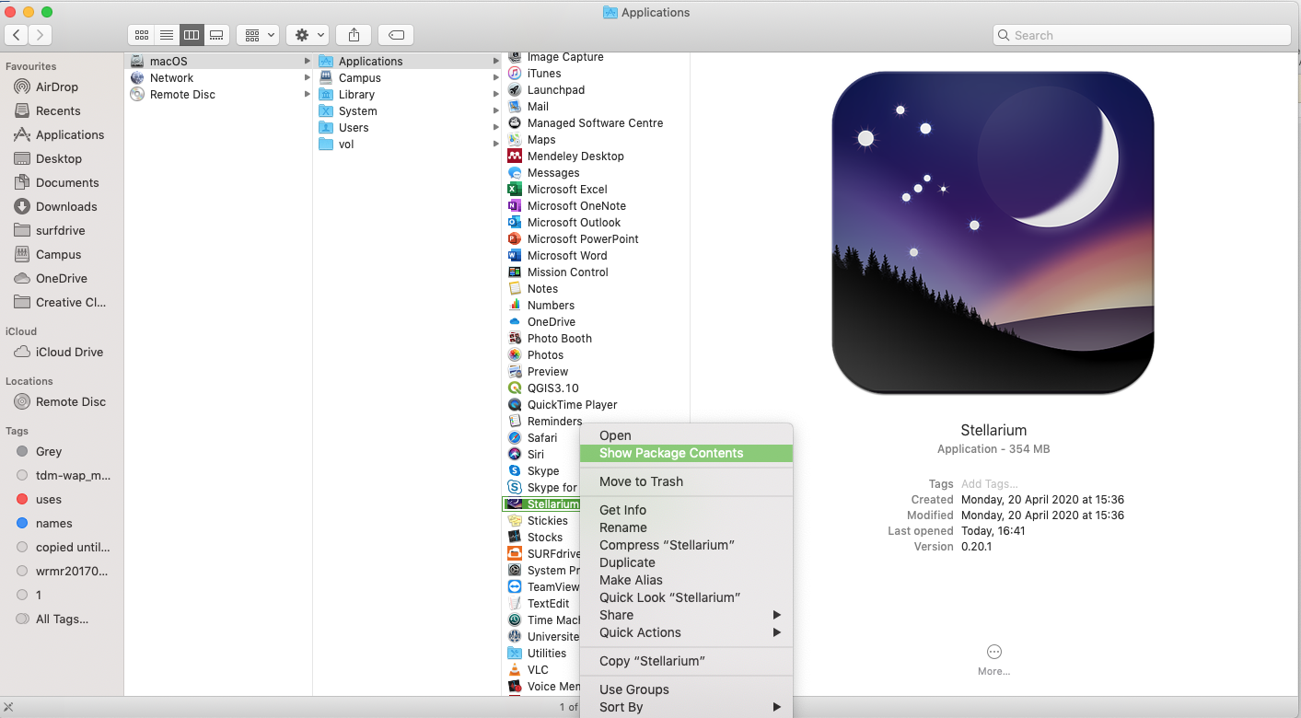

Task 7: Add your folder to the Stellarium skyculture folder

1. Navigate to the Stellarium folder on your computer (On Mac, Applications => Stellarium)
2. Open the folder (on Mac, right-click Stellarium icon and choose Show Package Content)
3. Next, navigate to the skycultures subfolder (resources => skycultures)
4. Drag and drop the whole renamed Lokono_john folder into the skycultures folder
5. Restart Stellarium

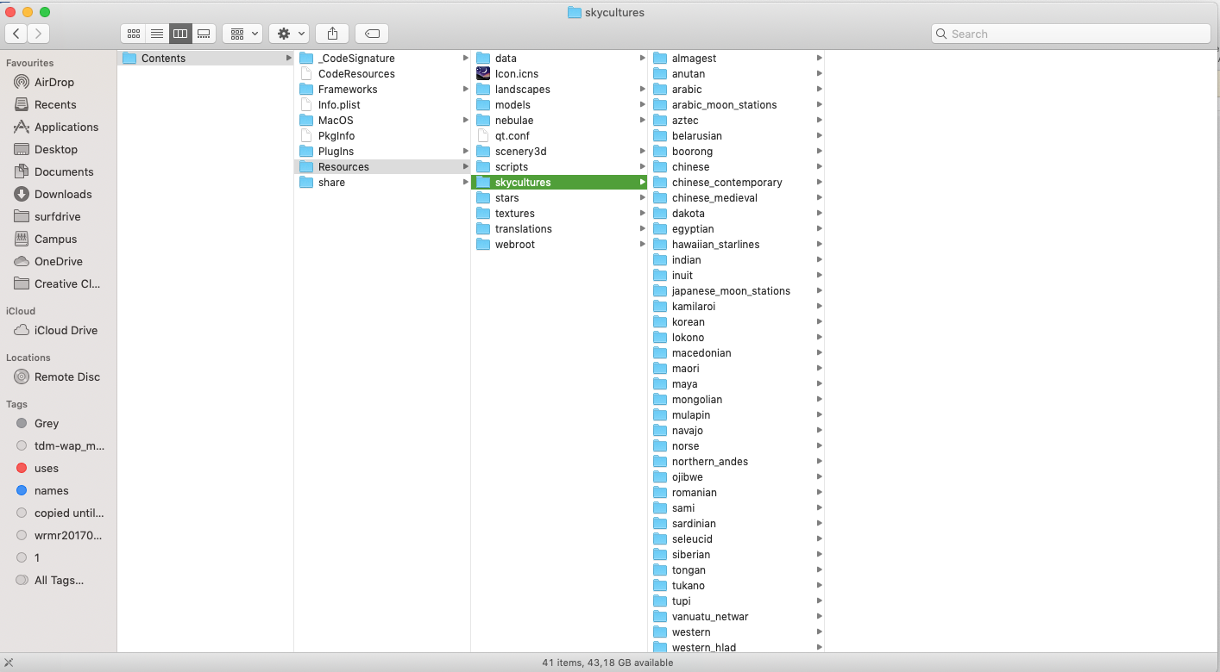

Result: When you restart Stellarium and go back to the Starlore tab under Sky and View Options Window, you should see Lokono_john skyculture listed in the left-hand column:

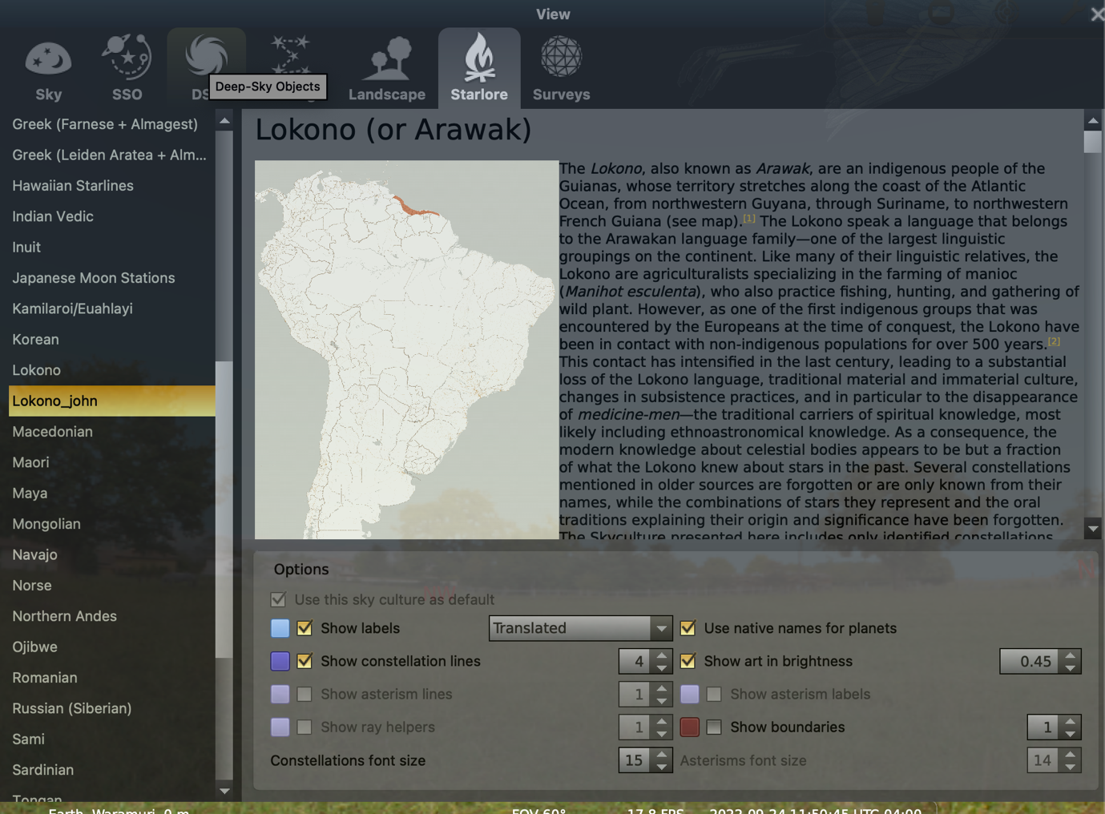

Task 8: Make Lokono_john your default skyculture

1. Tick Use this skyculture as default below the description of the skyculture

Changing the description of the skyculture

Task 8:
1. Navigate to your Lokono_name folder in Stellarium
2. Right-click the description.en.utf8 file
3. Select and copy the whole code

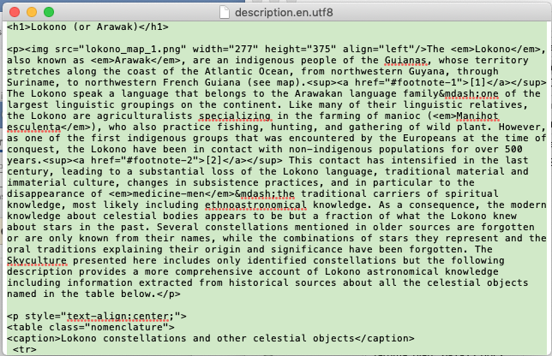

4. open an HTML editor website https://html-online.com/editor/
5. Paste the text from the description.en.utf8 file into the right-hand window

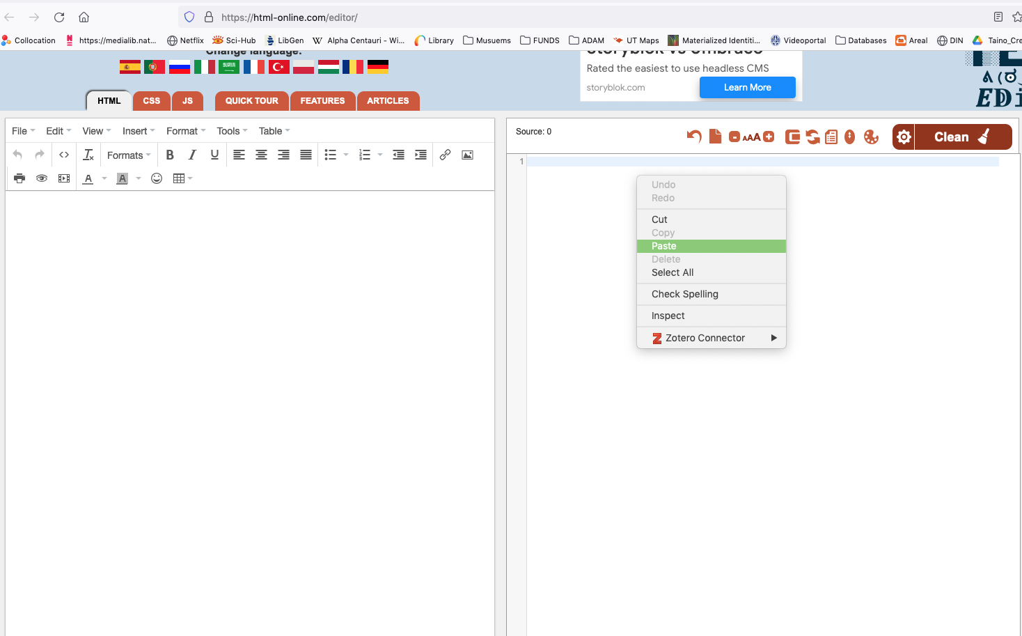

6. Edit the text in the left-hand window as you see fit
7. Minimally, change the title to “Lokono (or Arawak) by John” in the left-hand window
(notice the changes on the right-hand side)

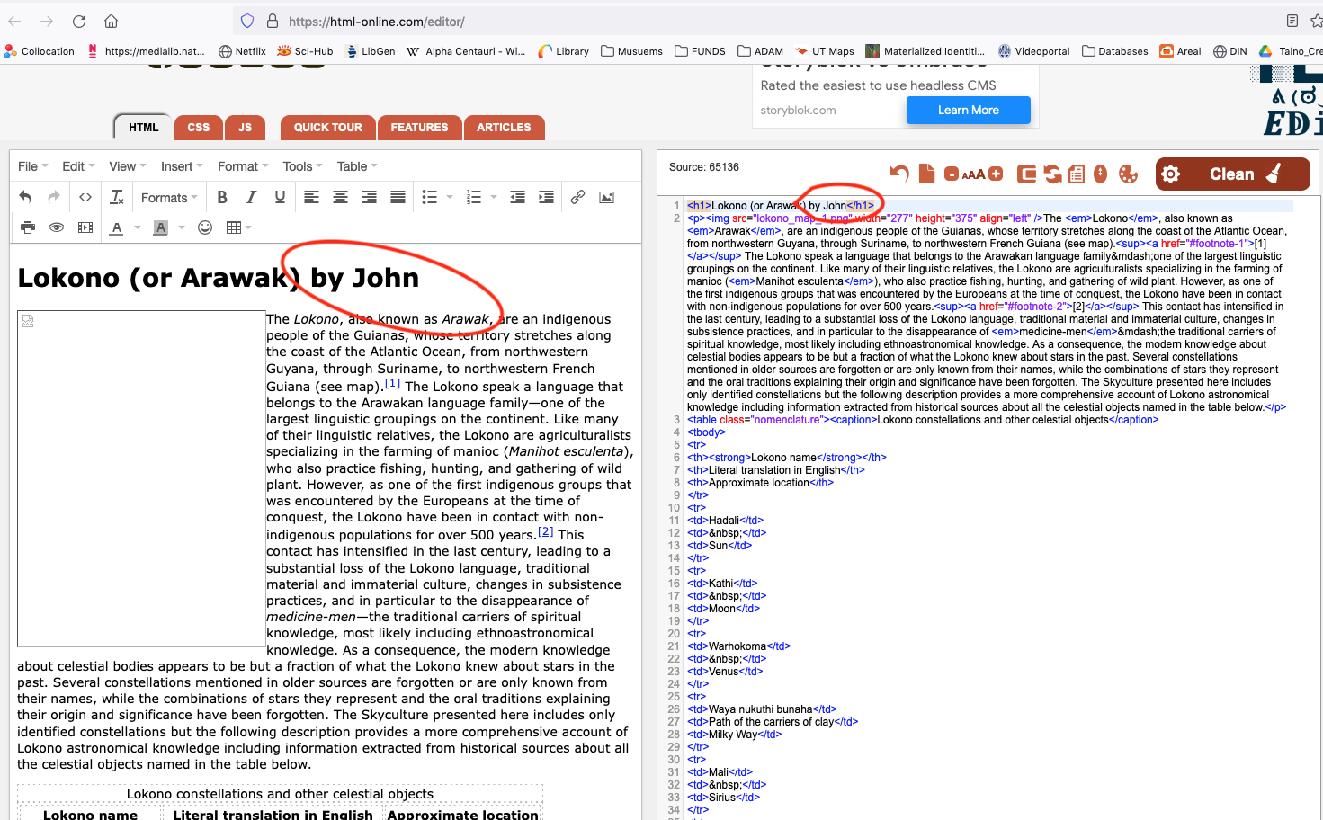

8. Copy the whole code from the right-hand window
9. Paste it back into the description.en.utf8 file.
10. Close and save file.
11. Check the results under Sky and Viewing Options Window:

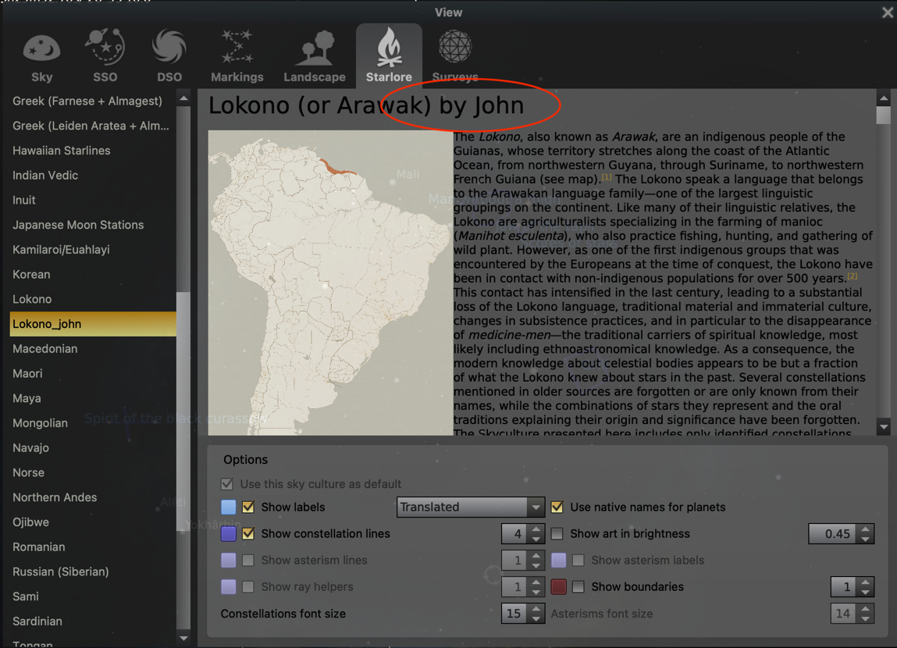

Adding a constellation

We will add one constellation to your new skyculture. We will add a real Lokono constellation, Awarhâkoya ‘Spirit of the cocoi heron’, which happens to correspond to the Big Dipper, which forms part of the Western constellation Ursa Major (see images).

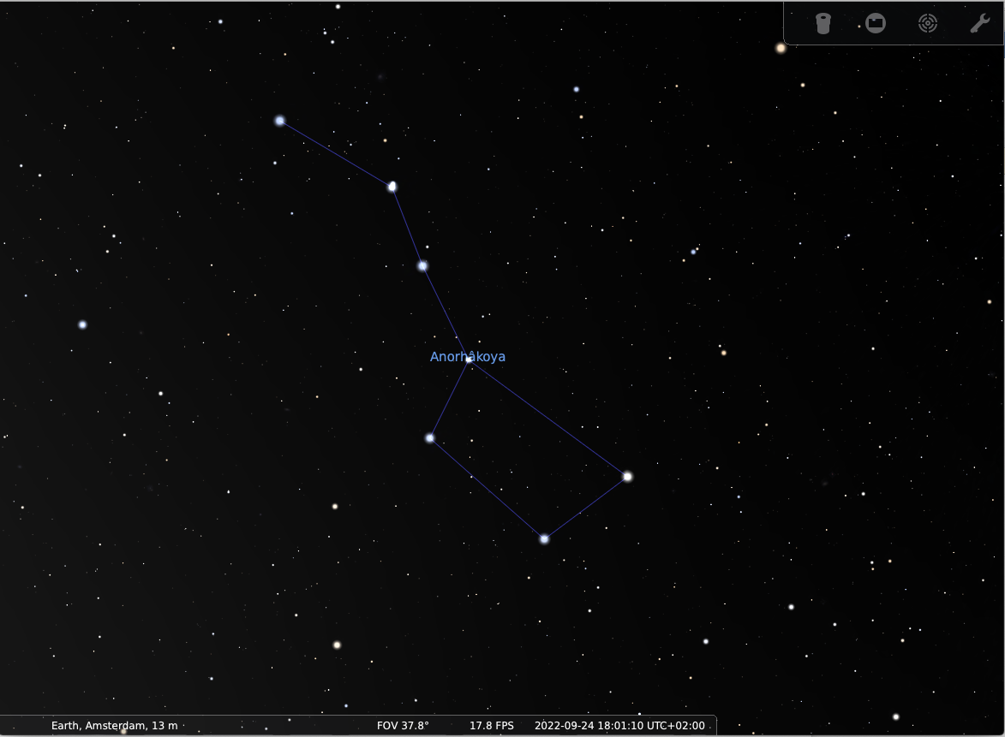

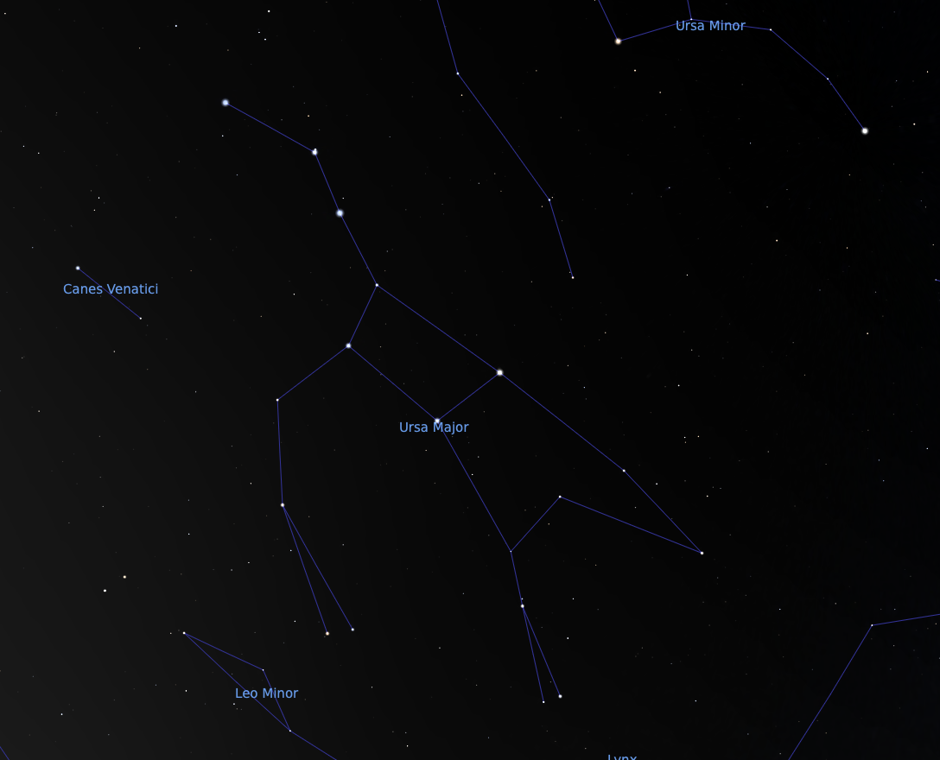

Adding the name of a new constellation

1. Navigate to your Lokono_name folder in Stellarium
2. Right-click the constellation_names.eng.fab file and open it in a text editor

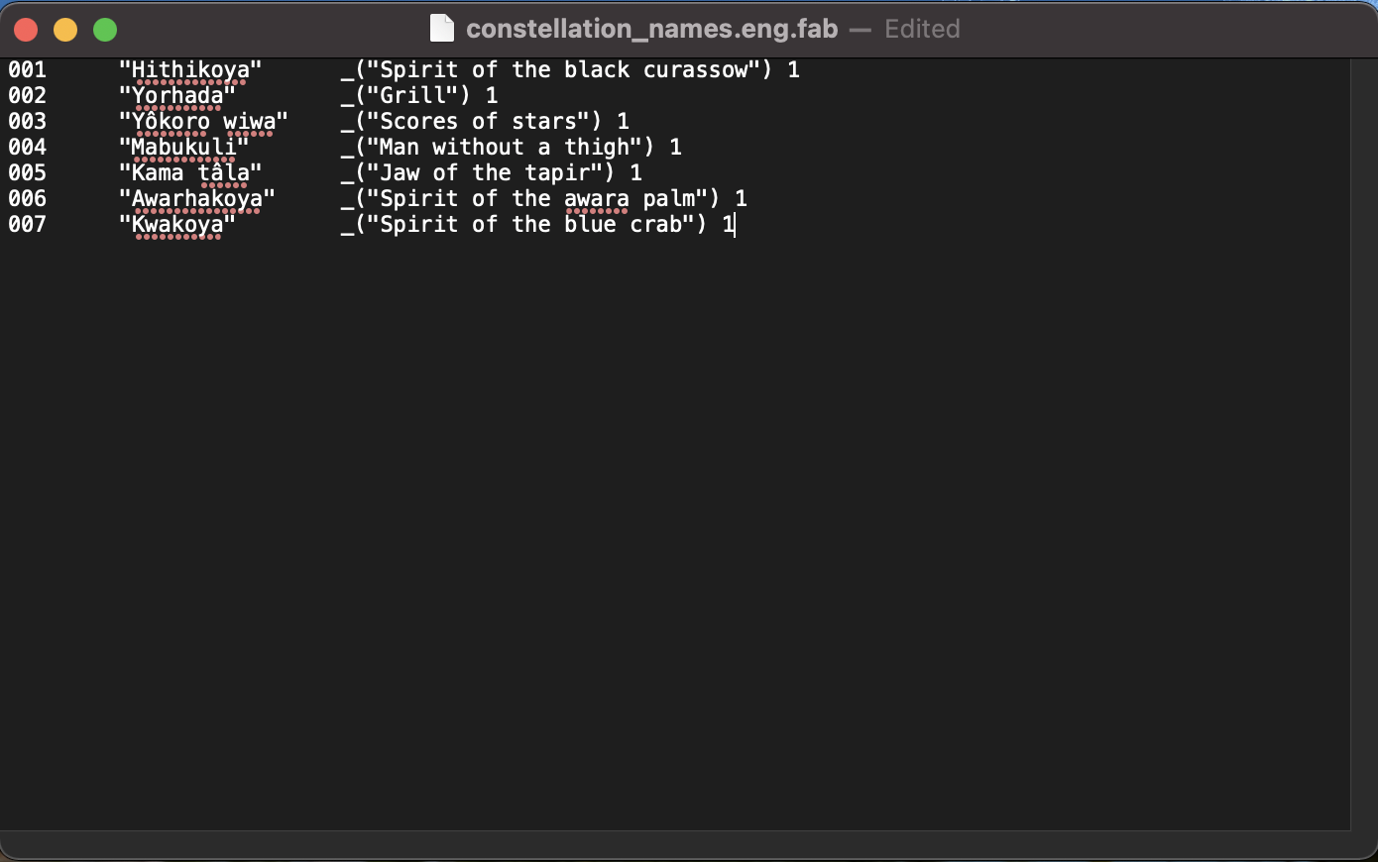

3. Copy the last line and paste it below the last line

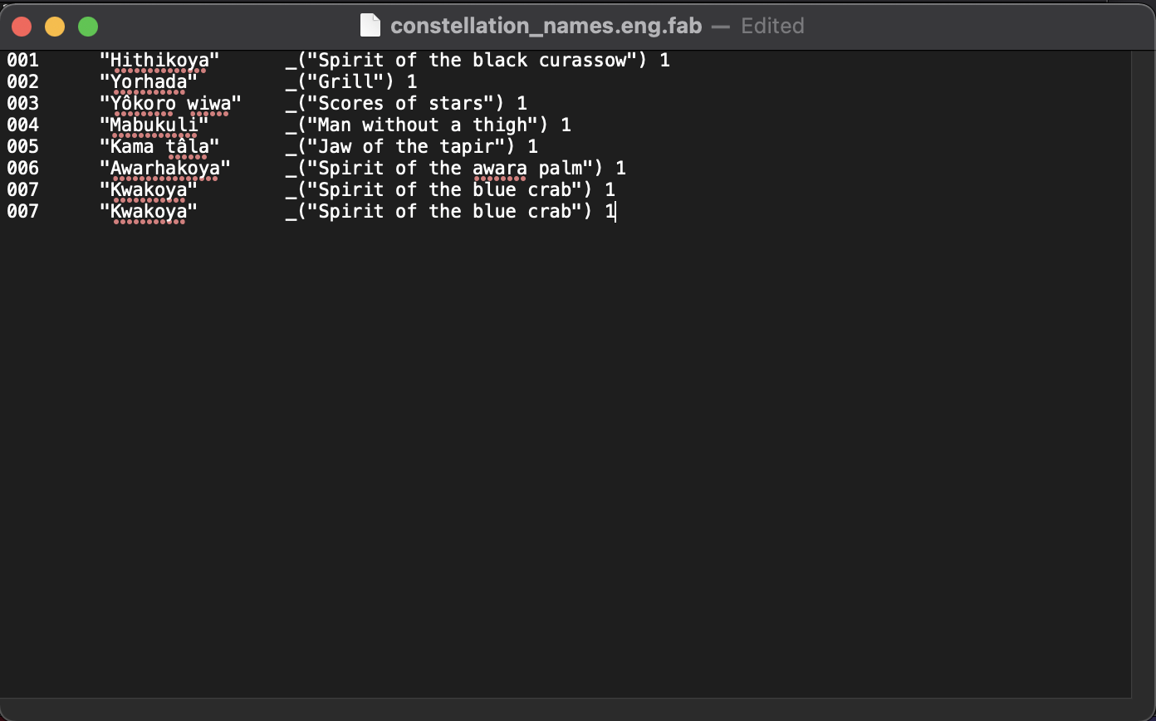

4. Change the numerical identifier in the first column to 008
5. Change the Lokono name in the second column to “Anorhâkoya”
6. Change the translation in the third column to “Spirit of the cocoi heron”
7. Warning: try not to change anything else but the data between “”.
8. Save file.

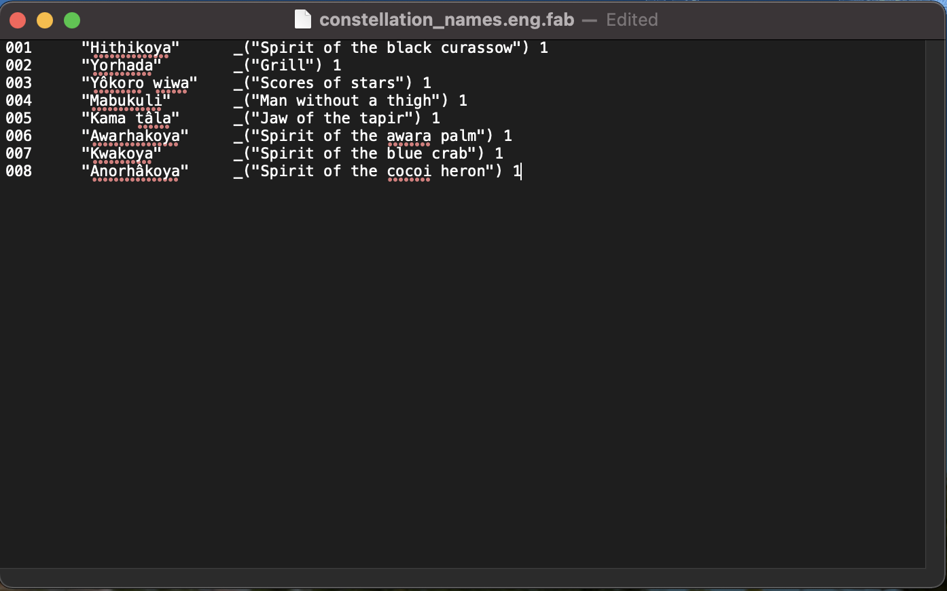

Result: since we didn’t tell Stellarium which stars form this pattern, Stellarium will not display anything new at this moment.

Identifying stars that form a constellation

To have Stellarium which stars form a pattern, we first need to note the HIP codes of the starts that form it. Normally, you would do that using a tablet or your phone in the field. In this case, we will use the desktop version. In this case, since Anorhâkoya overlaps with Big Dipper, we will use Western constellations.

Task 1. Identify the HIP codes of the stars that form Anorhâkoya

1. Choose Western constellations under Sky and Viewing options window

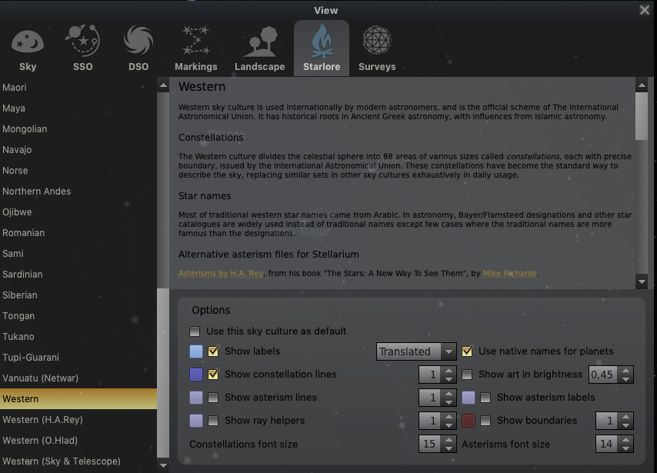

2. Open the Search window, and choose Constellations from the Lists tab

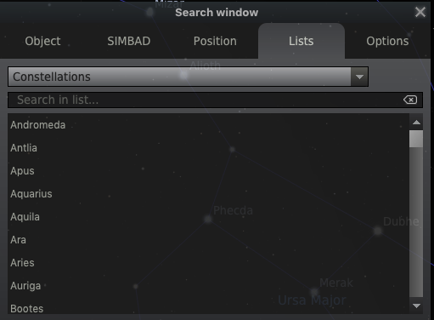

3. Type Ursa Major and click the result.

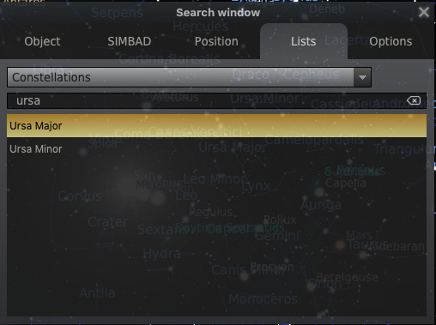

4. The screen should now center on Ursa Major
5. Zoom in on Ursa Major using your mouse scrolling function
6. Click the first star in the pattern: Stellarium will display your HIP code
7. Write down the HIP code of this star, e.g. 67301
8. Continue like this with other stars that form Awarhâkoya
9. Keep track of how the you want the stars to be connected with lines using this format:

1st line: HIP1 to HIP2
2nd line: HIP2 to HIP3
3rd line: HIP3 to HIP4
4th line: HIP4 to HIP5
5th line: HIP5 to HIP6
6th line: HIP6 to HIP7
7th line: HIP7 to HIP4

(in total there are 7 lines: make sure you get them all)
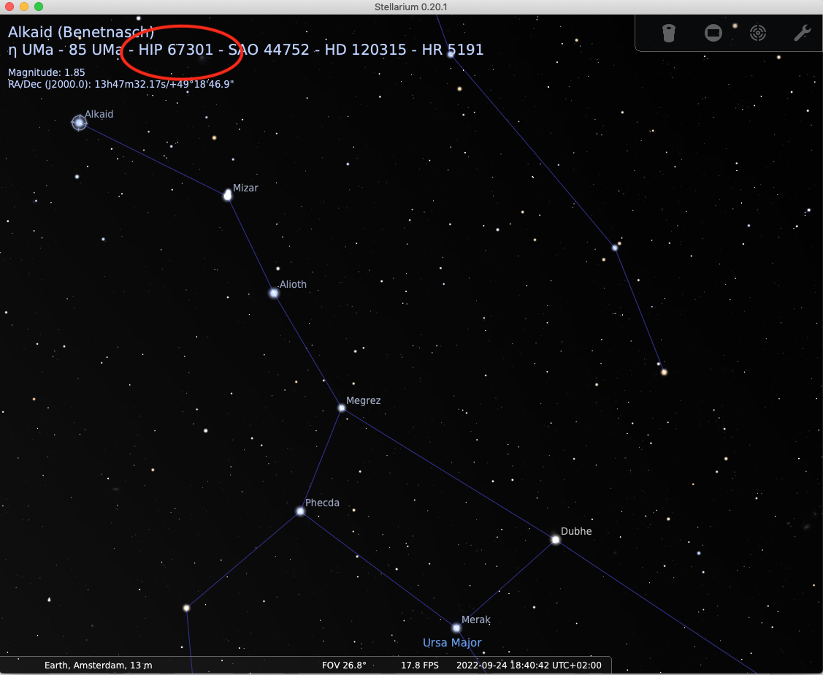

Adding lines codes to Anorhâkoya

1. Navigate to your Lokono_name folder in Stellarium
2. Right-click the constellationship.fab file and open it in a text editor
3. The numbers in the 1st column correspond to the names in the constellation_names file

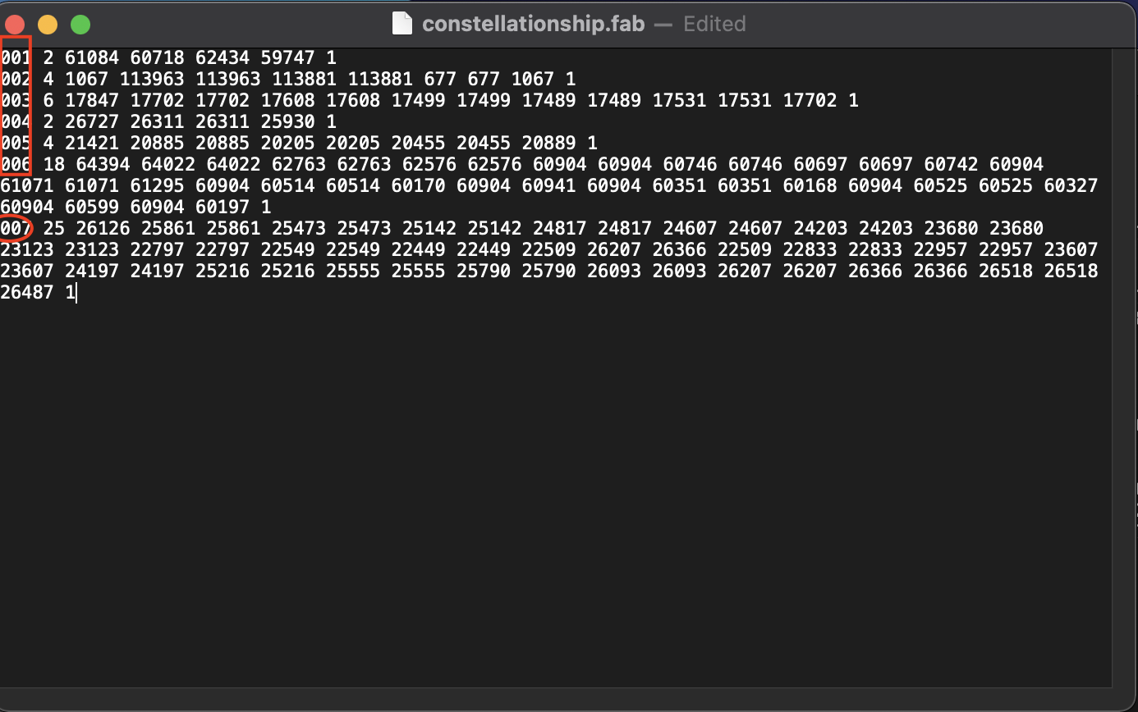

3. The numbers in the 2nd column say how many lines Stellarium must draw

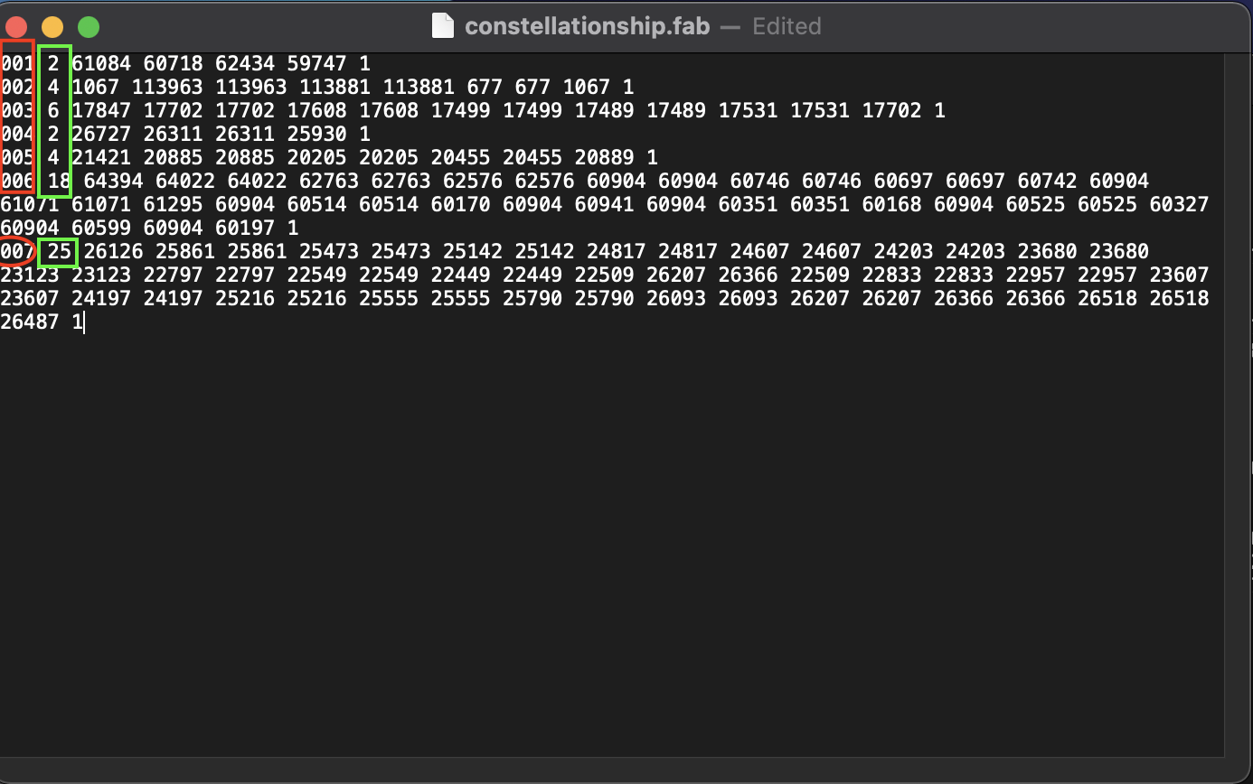

4. The remaining numbers are PAIRS of HIP codes between which a line must be drawn, e.g. for constellation number 001, there must be 2 lines, one tween 61084 and 60718, and another between 62434 and 59747.

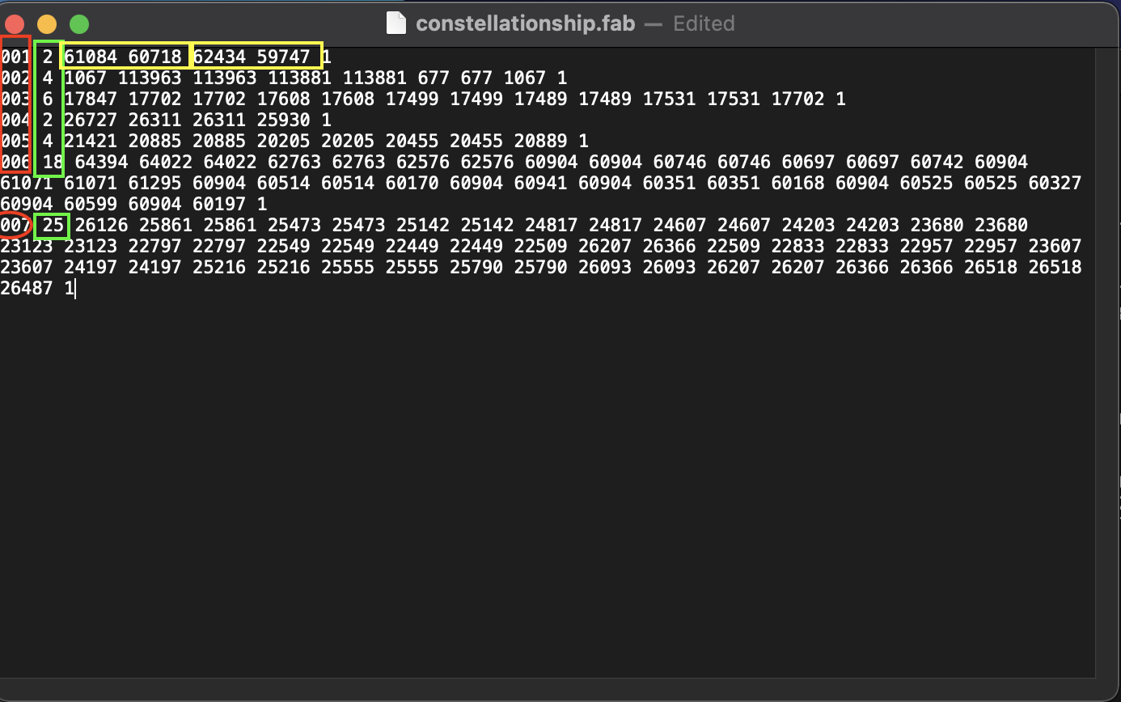

5. Now add the data for Anorhâkoya. First, give it the same numerical identifiers as in the constellation_names file (i.e. 008), then type the number of lines that form it (i.e. 7), and next type all seven pairs of HIP codes each corresponding to a single line.

6. Save file. When you now open Stellarium again (or merely switch to another skyculture and then back to yours), Anorhâkoya should be displayed on the screen.

Creating artwork for Anorhâkoya

In your skyculture folder, you also store artwork: digital image files that represent the constellation. There are several limitations on such files (format, size, black background).

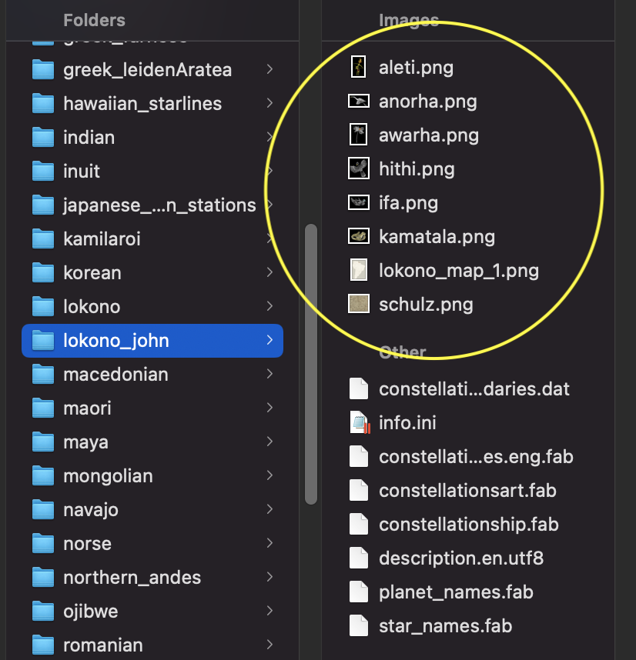

To create the files in our case, Leander Vermaning, a Lokono artist creates digital artwork straight away, but you can also make an analog artwork and then scan it. The way we work helps later with coordinating the image with the star pattern.

- First, we make a screenshot of the shape of the constellation in Stellarium.
- Second, we import the screenshot of the shape as one layer into an image editor
- Third, on top of that layer, on another layer, we draw the artwork.
- Next, we note the coordinates of three pixels corresponding to three stars in the pattern
- Finally, we export the layer with the artwork only as a png file and add it to the folder.

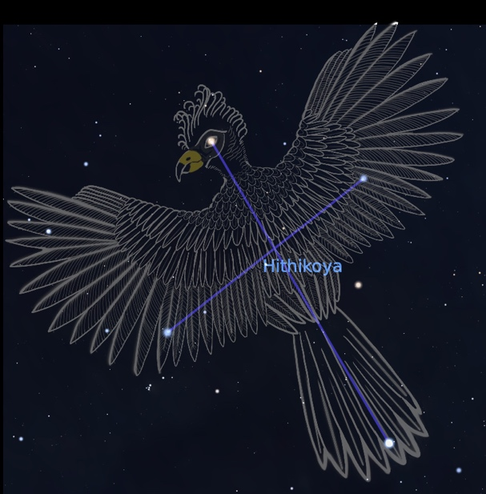

Coordinating artwork for Anorhâkoya

To coordinate an artwork with the star shape we have to edit the constellationsart.fab file. The 1st column give the numerical identifier of the constaltion (the same as in constellation_names and constellationships). The 2nd column list the name of the artwork file. The third column is a list of THREE TRIADS each consisting of: first, x coordinate of the pixel, second, the y coordinate of the pixel, and three, the HIP code of the stars with which the pixel is to be aligned.

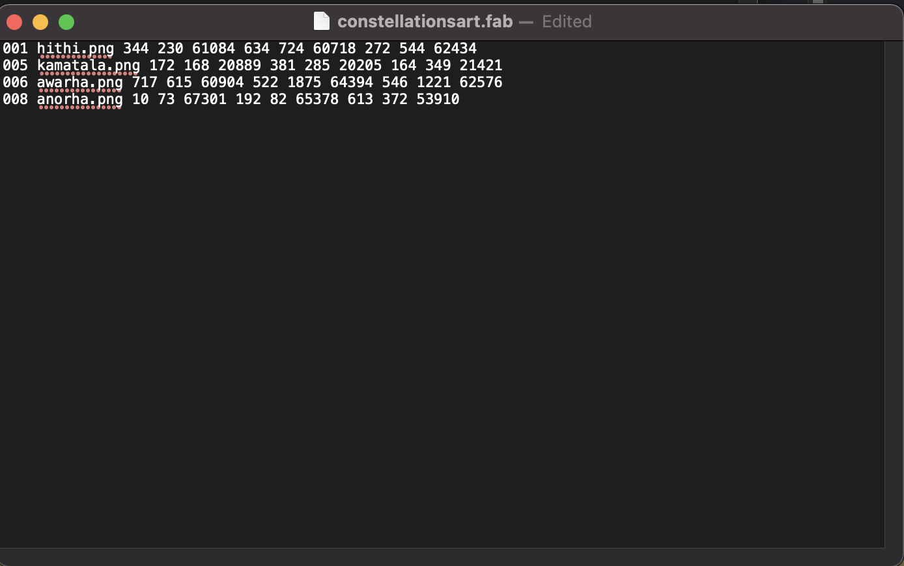

Task 9: Align the anorha.png file with the Anorhâkoya constellation

1. Copy the last line and past it below the last line
2. Change the numerical identifier to that of Anorhâkoya (i.e. 008) in the 1st column
3. Type the name of the artwork file in the 2nd column (i.e. anorha.png)
4. Coordinate three stars (using their HIP codes) with three pixels of the artwork

star with HIP 67301 with pixel with coordinates x=10, y=73
star with HIP 65378 with pixel with coordinates x=192, y=82
star with HIP 53910 with pixel with coordinates x=613 y=372

5. Save the file, open Stellarium, turn on Display artwork on the Lower Menu Bar.

Once you save the file and switch back and forth to your skyculture, the artwork should display in Stellarium.

